NAME : A.jyothsna

Reg no : 192211459

Sub code : CSA1024

Subject : Software engineering

for in industrial Application

INDEX :

|  |  |  |
| --- | --- | --- |
| s.no | Experinment number | Page number |
| 1 | Use case diagram for Online voting system | 1 |
| 2 | Use case diagram for Library management system | 3 |
| 3 | Quotient and remainder | 5 |
| 4 | Use case diagram for Online shopping system | 7 |
| 5 | Use case diagram for online railway reservation system | 9 |
| 6 | Use case diagram for hospital management system | 11 |
| 7 | Use case diagram for ATM system | 13 |
| 8 | Use case diagram for online college management system | 15 |
| 9 | Use case diagram for online Airline reservation system | 17 |
| 10 | Class diagram for online Airline reservation system | 19 |
| 11 | Class diagram for online voting system | 21 |
| 12 | Class diagram for library management system | 23 |
| 13 | Class diagram for online shopping system | 25 |
| 14 | Class diagram for online railway reservation system | 27 |
| 15 | Activity diagram for online voting system | 29 |
| 16 | Activity diagram for library management system | 31 |
| 17 | Activity diagram for online shopping system | 33 |
| 18 | Activity diagram for online railway reservation system | 35 |
| 19 | Activity diagram for hospital management system | 37 |
| 20 | Using raptor palindrome | 39 |
| 21 | Using raptor calculate Fibonacci series | 41 |
| 22 | Using raptor swap two characters | 43 |
| 23 | Using raptor display the length of the string | 45 |
| 24 | Using raptor find the number is prime or not | 47 |
| 25 | Find cyclomatic complexity 12 edges and 13 predictes nodes in graph 5 | 49 |
|  |  |  |
|  |  |  |
|  |  |  |

1. USE CARE diagram for Online Voting system using CASE tools

AIM:

To implement and execute online voting system

PROCEDURE:

Online voting system is a web based voting system that will help you elections easily and securely . this voting system can be used for casting votes during the elections held in colleges,etc.in this system the voter do not have to go polling booth to cast their votes.these is a data bases which all the name of the voters with their complete information is stored.the system Administration registers the votes by simply filling a registration form to register the votesn.After registration , the voter assigned with their secrect ID with which he/she can use to login to the system and cast his/her vote. If invalid/wrong details are submitted, then the person is not register to vote. After the user successfully registers themselves a link is sent on their mobile phone.

OBJECTIVE:

**The main objective of this project work is to design an on-line voting system which among others will be able to achieve the following targets; (ii) Nobody will have access to the votes before the official opening of the electronic ballot. (iii) The votes cast cannot be intercepted, modified or diverted.**

**OUT PUT:**

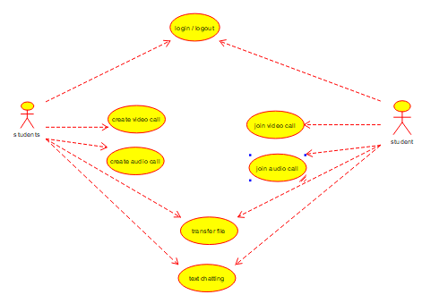

**RESULT:**

**The use case diagram for the online voting system is successfully completed.**

1. **USE case diagram for library management system**

**AIM:**

**TO IMPLEMENT AND EXCUTE LIBRARY MANAGEMENT SYSTEM**

**OBJECTIVE:**

In a traditional library the details of the members and the books in the library are recorded manually. The date of issue and return of books, overdue books, fines accrued are all entered in registers by the librarian and his assistants. The data automatically by RFID sensors reading the barcodes.

Procedure:

Library Management Systems are a great way to monitor books, add them, update information in it, search for the suitable one, issue it, and return it when needed.

This Library Management System Project is developed in Java, to provide all the features that a Library Management System should usually have and overcome the drawbacks of the present system such as:

* Paper-based record keeping.
* Mis-management of data due to manual and paper-based handling.
* A vast amount of time consumption in searching for books and library management.
* Book-thefts from the library.

OUT PUT:

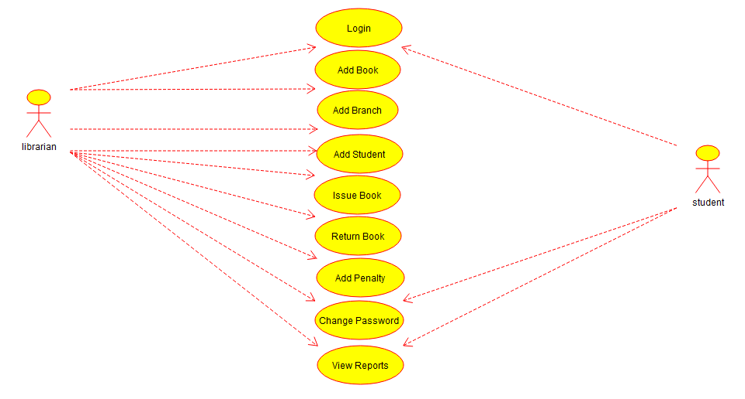

RESULT:

The use case diagram for the library management system is successfully completed.

3)Draw And Validate The Flowchart to compute the quotient and remainder.

AIM:

To implement and excute quotient and remainder.

Objective:

Raptor allows the user to write and excute the program using flowcharts.the simple lamguage and geographical components of raptor are designed to teach the major ideas of computer programming to the students .it is typically used in academics to teach introductory programming as well

Procedure:

Step1: from the raptor software application dragging the icons of assignment input and output

Step 2: I am taking 5 assignments , 1 input and 2 output and 2 loop for the effective running of the program

Step 3: filling the assignment ,input and output and loop columns to run the program

Output:

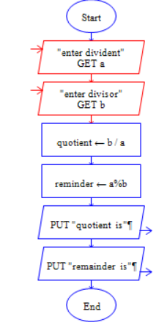

RESULT:

Finally the program is excuted

successfully

**4)USE case diagram for Online shopping system**

**AIM:**

**To implement and excute online shopping system**

**Objective:**

**intended to provide all stakeholders, including clients and project managers as well as develops and engineers, with a high-level view of the subject system and**

**communicate the highest level system requirements in non-technical terms.**

**The purpose of use case diagrams is to model what the system should do (What) without considering how it should be done at this stage (How) and to view the use of the system from the user's perspective (external view) rather than internally (implementation of these features).**

**Use Case diagrams have only 4 major elements:**

1. **The actors that the system you are describing interacts with:**
2. **The system itself (system boundary - the rectangle)**
3. **The use cases, or services, that the system knows how to perform, and**
4. **The lines (link) that represent relationships between these elements.**

Procedure:

**Web Customer** actor uses some web site to make purchases online. Top level use cases are **View Items**, **Make Purchase** and **Client Register**. View Items use case could be used by customer as top level use case if customer only wants to find and see some products. This use case could also be used as a part of Make Purchase use case. Client Register use case allows customer to register on the web site, for example to get some coupons or be invited to private sales. Note, that **Checkout** use case is included not available by itself - checkout is part of making purchase.

Except for the **Web Customer** actor there are several other actors which will be described below with detailed use cases.

Out put:

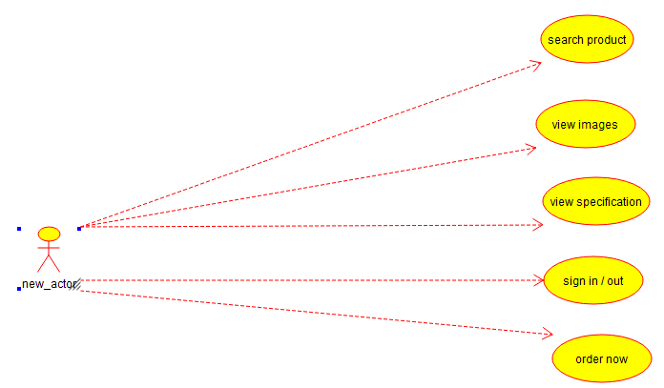

Result:

The USE CASE diagram for the online shopping system is successfully completed

**5) USE CASE diagram for online Railway Reservation system**

**AIM:**

**To implement and excute Reservation system**

**Objective:**

**The main objective of the Railway Reservation system is to manage the details of Train ,Booking Payment ,seat,Ticket.it manages all the information about Train ,customer ,Ticket,Train .The project is totally built at administrative and thus only the administrator is guaranteed the acess.The purpose of**

**The project is to build an application program to reduce the manual work for managing the train,booking,customer,payment.it tracks all the details about the payment,seat,ticket.**

**Procedure:**

The online railway ticket reservation system is developed using ASP.NET with C# as the backend in the .NET Framework. f1.3 Objectives: The objective of the online railway ticket reservation system Project is to design software to fully automate the process of issuing a railway ticket. That is:- 1. To create a database of the trains 2

**Output:**

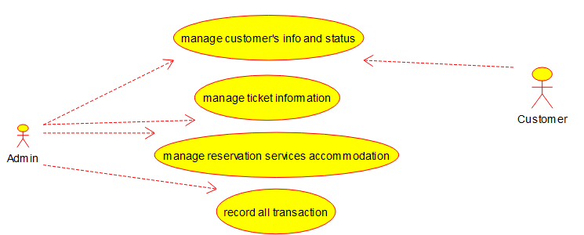

**RESULT:**

**The USE CASE diagram for the online Railway reservation system is successfully completed.**

**6) USE -CASE diagram for hospital management system**

**AIM:**

**To implement and excute hospital management system**

**Objective:**

HOSPITAL MANAGEMENT is an integrated Hospital Information System, which addresses all the major functional areas of multi-specialty hospitals. The HOSPITAL MANAGEMENT enables better patient care, patient safety, patient confidentiality, efficiency, reduced costs and better management information system

Procedure:

Hospital Management System is an online management system that is used to manage the hospital, I am explaining various functionality of the hospital management system. You can check. I am an expert in computer science assignment help. You can enjoy taking my programming assignment services at once. I hope you will love my services.

If you want a hospital management System project in any programming languages (PHP, Python, Java, Asp.net, Ruby on Rail, C, and C++). I can develop it for you.  So how do you want to contact me? You can fill the form . Once you will fill that form, I will be connecting you within few minutes. I have worked for more than 1500 clients.

OUTPUT:

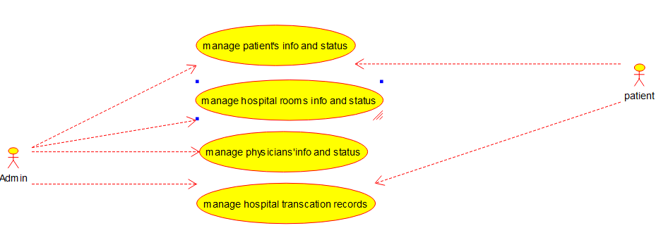

RESULT:

The USE CASE diagram for the hospital management system is successfully completed

5)USE CASE diagram for ATM system

AIM:

To Implement and excute ATM system

Objective:

Reduces the maintenance costs of the ATM

Optimizes the availability of ATMs.

Imports settlement data directly.

Eliminates the need for manual entry

**Procedure:**

**The term ATM stands for automated teller machine.**

**It is an electronic device that is used by only bank**

**customers to process account transactions. The**

**access their accounts through a special type of**

**plastic card that is encoded with user information**

**on a magnetic strip. The strip contains an**

**identification code that is transmitted to the bank’s**

**central computer by modem. The users insert the**

**card into ATMs to access the account and process**

**their account transactions. The automated teller**

**machine was invented by John Shepherd-Barron in**

**the year 1960. This article discusses an overview of**

**the automated teller machine (ATM).**

**Output:**

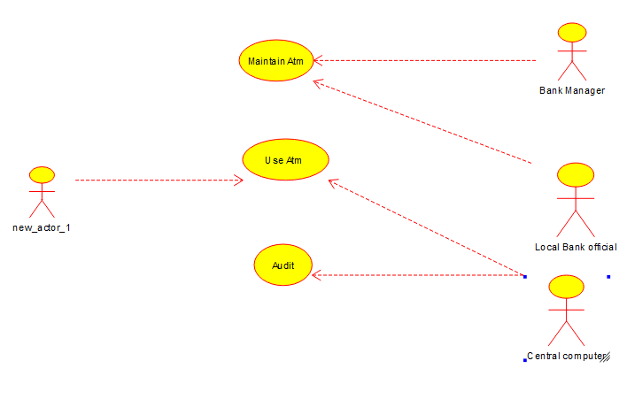

**Result:**

**Use case diagram for Atm system is successfully completed.**

**7) Use case diagram for online college management system**

**AIM:**

**To implement and excute online college management system**

**Objective:** This section will go in detail about how the performance management system is set up across the entire organization.

**The activities included are:**

* Setting goals and objectives,
* Reviewing employee progress toward achievement of goals and objectives,
* Making progress reviews,
* Seeking feedback

**Procedure:**

One of the most important aspects of an organization’s performance management system is having a purpose. This is the reason why companies have to set the system up in specific ways, or else employees in the organization won’t see it as an essential component of their day-to-day responsibilities.

When their superiors are not continuously setting and communicating performance goals, employees will feel useless, unmotivated, and unproductive. It is for this reason that companies need to dedicate a great deal of resources to performance management systems objectives.

Performance management is a company’s tool for managing performance, which will lead to the achievement of the organization’s strategic goals. The main purpose of a performance management system is to help an organization encourage, motivate and reward its employees in such a manner that they will work at peak efficiency and produce the best results. In order to achieve this objective, organizations have devised performance appraisal systems.

Output:

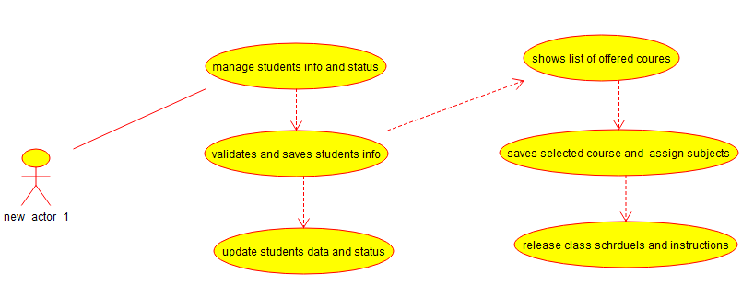

Result:

USE CASE diagram for online college management system is successfully completed.

5)USE CASE diagram for online Airline Reservation system

AIM:

To implement and excute online Airline Reservation system

Objective:

1. Provide a seat selector tool that will be used by both the passenger and the airline authorized employee to manage booking information.

2. Provide the proposed project the capability to book different kind of passenger.

3. Provide a ticketless flight travel using the proposed project ticketing system feature

Procedure:

The airline reservation system is a web-

based flight booking engine that is used to conduct flight

bookings. It involves Airline schedules, fare tariffs,

passenger reservations, and PNRs. The flight booking

engine is specially designed for travel agencies to

simplify the booking process and help their travellers

book one-way, round-trip, and multi-destinations on a

single platform. An airline booking engine also shows

dynamic packages like airline + hotel, hotels + holiday

packages, and hotels + cars. It is capable of conducting

countless transactions related to bookings in very little

time.

Output:

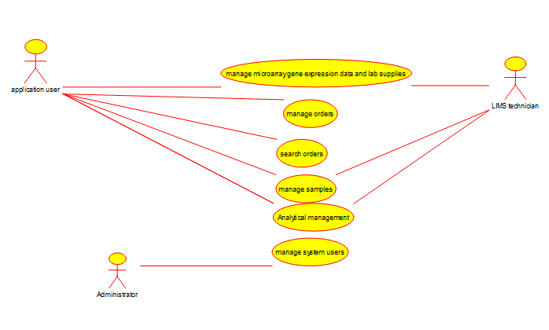

Result:

USE CASE diagraw for online airline reservation system is successfully completed.

5)Class diagram for online Airline reservation system.

AIM:

TO implement and excute class diagram for online Airline reservation system.

OBJECTIVE:

1. Provide a seat selector tool that will be used by both the passenger and the airline authorized employee to manage booking information.  
  
          2. Provide the proposed project the capability to book different kind of passenger.  
  
          3. Provide a ticketless flight travel using the proposed project ticketing system feature  
  
          4. Build the proposed project with the capability to include special handling procedure to a booking reference of a specific                  
  
          5. Build the proposed project with the capability to make rebooking, and re-routing option. Also the capability of the system to make re-issuance of tickets. Refunding and processing of flown ticket will also be included.  
  
          6.  Provide an online booking facility to be used by the client of the company as a method of delivering services to the airline

7. Provide a secured online booking facility to be used by the airline authorized employee to manage the reservation .   
8. Provide a secured online booking facility to be used by the airline authorized employee to manage the proposed system online facility.

9. Provide an alternative system that will be used

nd interfaced by the authorized airline employe

manage the system facility and utlity.

Procedure:

It contains the class attributes, methods as well

as the relationships between classes. The mentioned

contents makes sure that your Airline Reservation

system development must inline with what should be

its functions.

Here’s what you need to know about the UML Class

Diagram Airline Reservation System Project. It must

contain all the required information and must be

complete in details.

From the Classes, its attributes and methods up to its

visibility and relationships must be arrange and

declared thoroughly. Now you must know the needed

information before doing your UML Class Diagram

Airline Reservation SYSTEM.

OUTPUT:

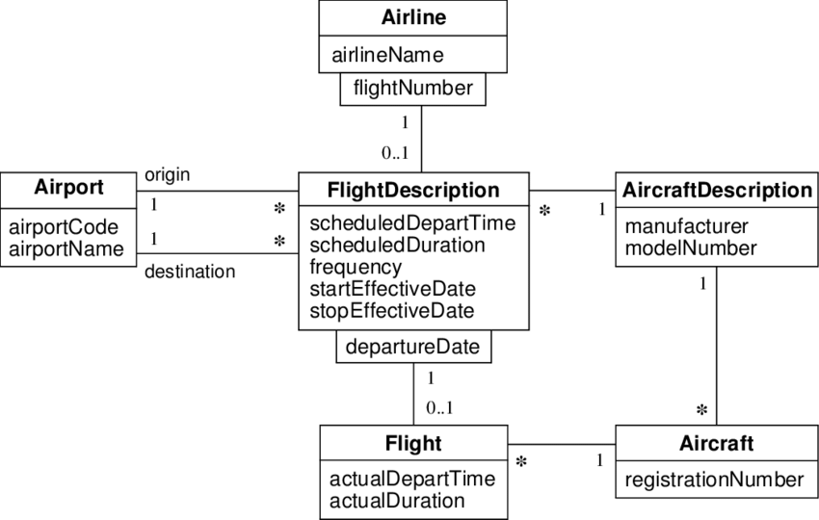

Result:

Class diagram for online reservation system is successfully completed.

1. Class diagram for online voting system

AIM:

To implement and excute class diagram for online voting system.

OBJECTIVE:

Voting Management System Class Diagram describes the structure of a Voting Management System classes, their attributes, operations (or methods), and the relationships among objects. The main classes of the Voting Management System are Vote, Citizen, Voter List, Votinng Center, Voting Machine, Candidate.

PROCEDURE:

This Online Voting System Diagram is an example of a Chen diagram for an online voting system. Online voting systems are software platforms used to conduct votes and elections securely. As a digital platform, they eliminate the need to vote in person. Online voting tools and online election voting systems assist you in making important decisions by collecting your group's input in a systematic and verifiable manner. In all of these cases, an online voting system like the one shown in this Online Voting System Diagram will allow you to make better decisions, justify those decisions, and share proof that these decisions were made following your group's standards.

Output:

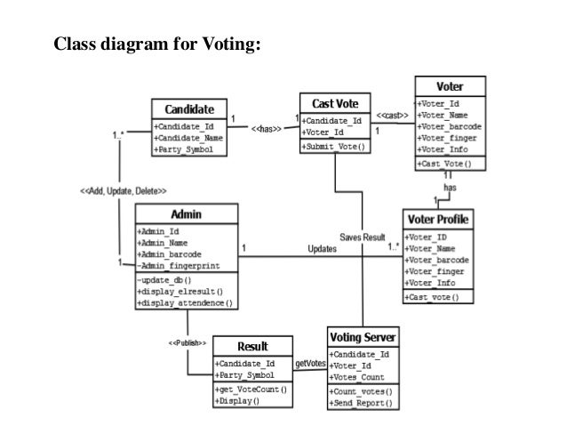

RESULT:

Clas diagram for online voting system is successfully completed.

10) class diagram for online Airline reservation system

Aim:

To implement and excute online airline reservation system

Objective:

The main objective of the Airlines Reservation System is to manage the details of Airlines Ticket,Flights,Customer,Booking Counter,Venders. It manages all the information about Airlines Ticket, Bookings, Venders, Airlines Ticket. Reservation, Passengar, Ticket Booking, Employee, Airline Enquiry. Reservation Class : Manage all the operations of Reservation Ticket Booking Class : Manage all the operations of Ticket Booking Airline Enquiry Class : Manage all the operations of Airline Enquiry.

Procedure:

* + This is a Component diagram of Airline Booking System which shows components, provided and required interfaces, ports, and relationships between the Booking Enquiry, Passengar Reservation, Airlines Booking, Airline Enquiry and Ticket Booking.
  + The main activity involved in this UML Activity Diagram of Airlines Reservation System are as follows: Admin User can search Airlines, description of a selected Airlines, add Airlines, update Airlines and delete Airlines. Its shows the activity flow of editing, adding and updating of Passenger.

Output:

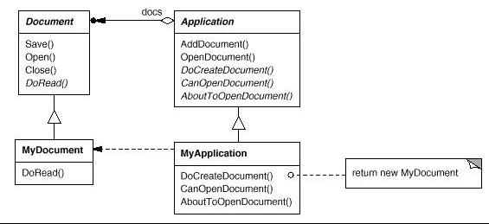

Result:

Class diagram for online airline reservation system is successfully completed .

11)class diagram for online voting system

Aim:

To implement and excute class diagram for online voting system.

Objective:

Elections are believed to be the key pillars of democracy and voting is one of the electoral processes that ensure the sustenance of democracy in any civil society. In this paper, we developed an electronic voting system, which will eliminate rigging and manipulation of results to its barest minimum, this problem is mostly associated with the manua...

Procedure:

In 2007, the desire to reclaim INEC's lost integrity, improve the veracity of election results, and exonerate INEC from public accusations of colluding with the ruling party to manipulate election results prompted the development of the Electronic Voting Machine (EVM) (Idris & Yusof, 2015). This is coupled with citizens' desire to elect credible and committed leaders for infrastructure development and the need to reduce post-election violence, which has claimed the lives of many innocent people in previous elections (Adebayo, Ugiomoh, & AbdulMalik, 2013). The burdens associated with manual elections in Nigeria range from the cost of paper ballot elections, with their massive logistics requirements, movements of multitudes of ad hoc voting staff and security officials, high-security printing costs to slow and ponderous counting, frequently open to manipulation and fraud, calls for a transition to e-voting for Nigeria.

OUTPUT:

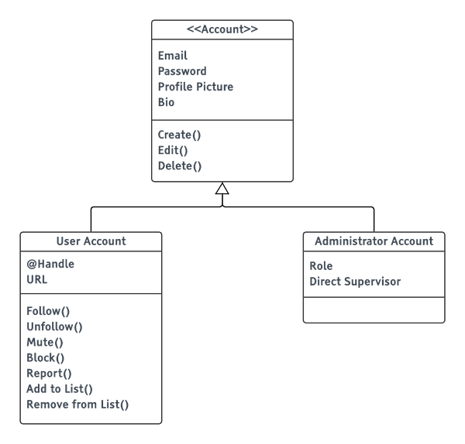

RESULT:

Class diagram for online voting system is successfully completed.

12)Class diagram for Library management system

AIM:

To implement and excute class diagram for library management system

Objective:

**Classes of Library Management System :**

* **Library Management System class –**  
  It manages all operations of Library Management System. It is central part of organization for which software is being designed.
* **User Class –**  
  It manages all operations of user.
* **Librarian Class –** It manages all operations of Librarian.
* **Book Class –**  
  It manages all operations of books. It is basic building block of system.
* **Account Class –**  
  It manages all operations of account.
* **Library database Class –**  
  It manages all operations of library database.
* **Staff Class –**  
  It manages all operations of staff.
* **Student Class –**  
  It manages all operations of student.

Procedure:

1) User who registers himself as a new user initially is regarded as staff or student for the library system.

* + For the user to get registered as a new user, registration forms are available that is needed to be fulfilled by the user.
  + After registration, a library card is issued to the user by the librarian. On the library card, an ID is assigned to cardholder or user.

1. After getting the library card, a new book is requested by the user as per there requirement.
2. After, requesting, the desired book or the

requested book is reserved by the user that means no other user can request for that book.

1. Now, the user can renew a book that means the user can get a new due date for the desired book if the user has renewed them.
2. If the user somehow forgets to return the book before the due date, then the user pays fine. Or if the user forgets to renew
3. that book.
4. Now, the user can renew a book that means the user can get a new due date for the desired book if the user has renewed them.
5. If the user somehow forgets to return the book before the due date, then the user pays fine. Or if the user forgets to renew the book till the due date, then the book will be overdue and the user pays fine.
6. User can fill the feedback form available if they want to.Librarian has a key role in this system. Librarian adds the records in the library database about each student or user every time issuing the book or returning the book, or paying fine.

* Librarian also deletes the record of a particular student if the student leaves the college or passed out from the college. If the book no longer exists in the library, then the record of the particular book is also deleted.
* Updating database is the important role of Librarian.

OUTPUT:

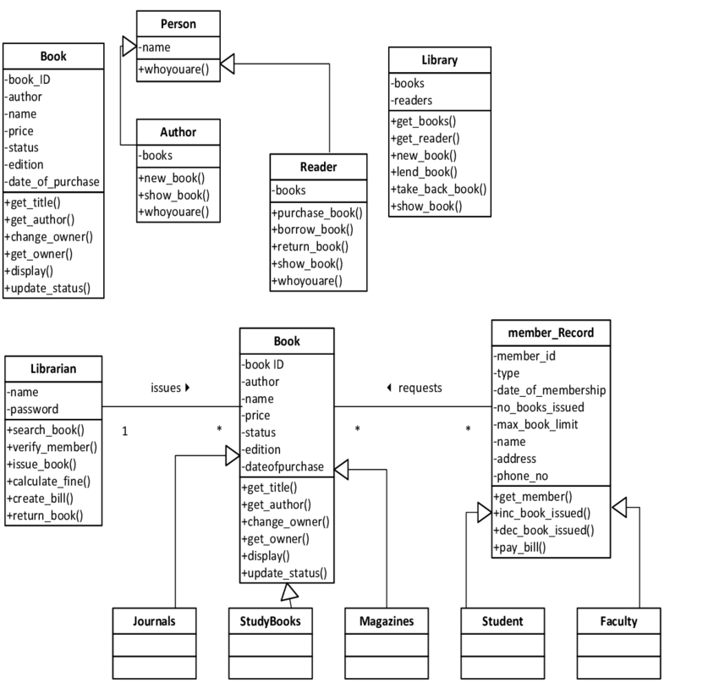

RESULT:

Class diagram for library management system is successfully completed.

13)Class diagram for online shopping system

AIM:

To implement and excute online shopping system

Objective:

1. **Online shopping class diagram template to visualize classes and relationships in an online shopping system. Use this example to create your own shopping class diagram.**
2. **You can easily edit this template using Creately's class diagram tool You can export it in multiple formats like JPEG, PNG and SVG and easily add it to Word documents, Powerpoint (PPT) presentations, Excel or any other documents. You can export it as a PDF for high-quality printouts.**

**PROCEDURE:**

example of UML Class diagram which shows a domain model for online shopping. The purpose of the diagram is to introduce some common terms, "dictionary" for online shopping - Customer, Web User, Account, Shopping Cart, Product, Order, Payment, etc. and relationships between. It could be used as a common ground between business analysts and software developers.

Each customer has unique id and is linked to exactly one **account**. Account owns shopping cart and orders. Customer could register as a web user to be able to buy items online. Customer is not required to be a web user because purchases could also be made by phone or by ordering from catalogues. Web user has login name which also serves as unique id. Web user could be in several states - new, active, temporary blocked, or banned, and be linked to a **shopping cart**. Shopping cart belongs to account.

**OUTPUT:**

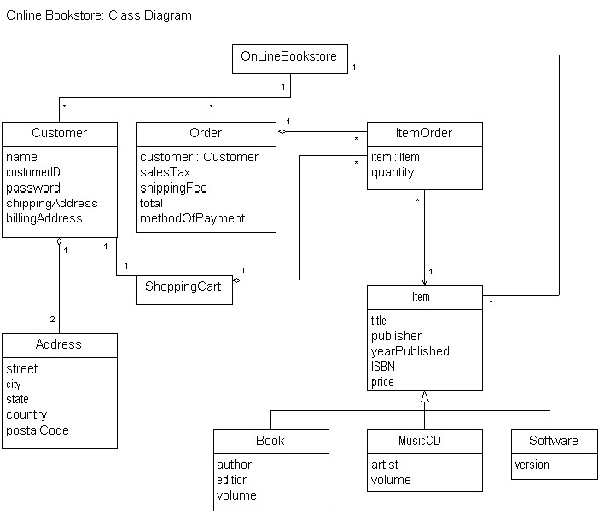

**RESULT:**

**CLASS DIAGRAM FOR ONLINE SHOPPING SYSTEM IS SUCCESSFULLY COMPLETED.**

**14)CLASS DIAGRAM FOR ONLINE RAILWAY RESERVATION SYSTEM**

**AIM:**

**To Implement and excute online railway reservation system**

**Objective:**

The ***Online Railway Reservation System Class Diagram*** is a designed illustration of the system’s attributes and classes. The illustration shows how the classes were used and plotted in the system. It also guides the programmers and developers on how should the Online railways Reservation System work.

* This UML Class Diagram is made to guide programmers along with the online Railway Reservation system development. It contains the class attributes, methods as well as the relationships between classes.
* These mentioned contents makes sure that your Railway Reservation system development must inline with what should be its function.

Procedure:

In Indian Railways transport system and in

most other public transport system a passenger

cannot book for a ticket after the charting of train

is done and a seat remains unused if a passenger

did not board a train or cancels his ticket after the

charting of train is done our approach to overcome

it is by a dynamic seat allocation system using QR

Code containing the URL to an online website for

railway reservation has been developed. In a QR

code a passenger specific URL is stored, when

Hand held Terminal device running on android OS

encodes this URL by the Check-in an passenger

passenger who don’t board on the train his QR

code check-in procedure is not done and after the

specific time interval the ticket for it is

automatically made available.

Output:

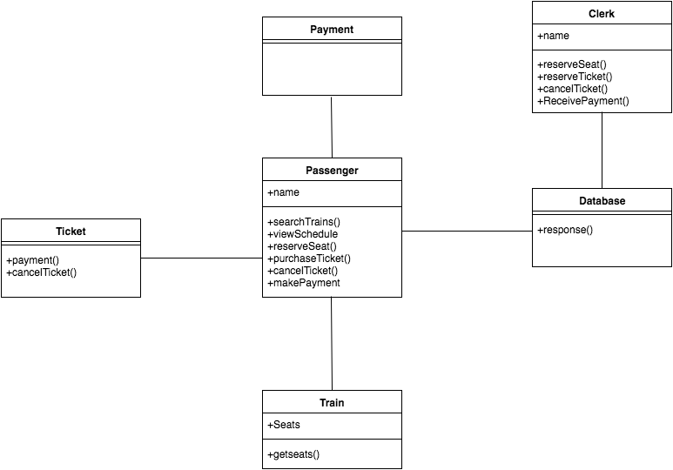

Result:

Class diagram for online railway reservation system is successfully completed.

15) Activity diagram for online voting system

AIM:

To implement and excute Activity diagram for online voting system

Objective:

* The ‘Online Voting System’ is a web based voting platform for conducting elections online. This system seeks to use face recognition algorithm for voter identity authentication to enhance the security of the electioneering process and ultimately providing an online platform which enables all eligible voters to exercise this activity from any location. The user must sign in/login using their respective credentials and they will be logged in into the system only after the face recognition authentication is successful. Thereafter, the voter can cast their vote securely and logout of the system. Hence, this project based on Online Voting System could be used for conducting secure and fair elections online.

Procedure:

* The voting systems currently in use in the country are Electronic Voting Machines (EVM) and Secret Ballet Voting, both of which require a large amount of manpower and are extremely time-consuming processes. The election officers must then check their Voter's Id in the voters' list of booths, and if the information is present, the voter can vote in that booth. The EVMs must be checked and transported to various parts of the country where the election is being held. It also necessitates manual labour and security. The counting of votes cast in EVMs requires manpower as well and takes an entire day, while ballet voting is entirely manual. Because all of this work is done by hand, there is a high risk of malpractice, making the conduct of a free and fair election extremely difficult

OUTPUT:

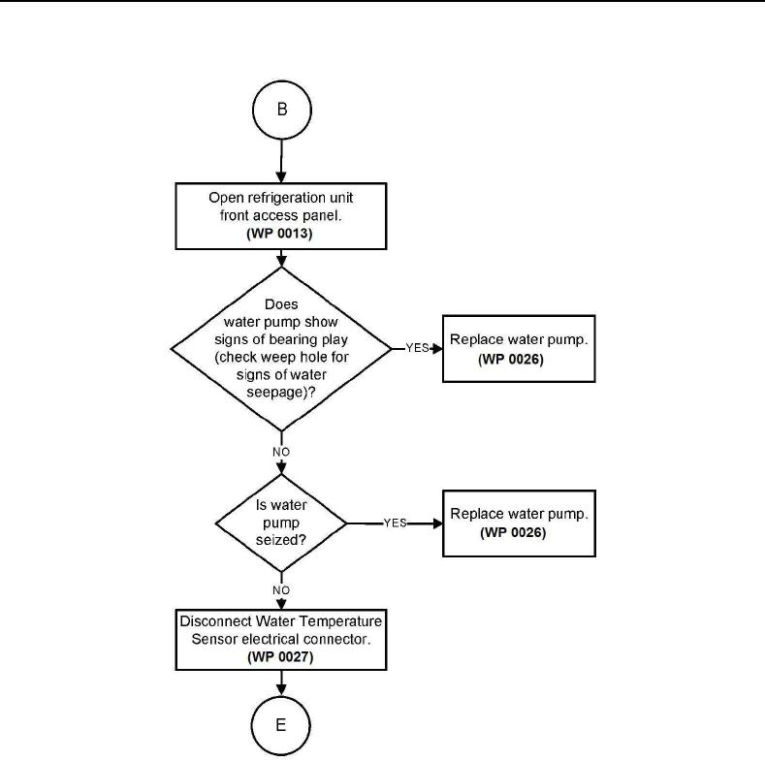

RESULT:

Activity diagram for online voting system is successfully completed.

16) Activity diagram for Library management system .

AIM:

To implement and excute Activity diagram for library management system

Objective:

The library management system software should be user-friendly and cost effective. It should be in tune with the establishment’s needs and compatible with the existing technology.  
  
  
A library should use a software system that helps in effectively managing the data in a library. The library database includes all relevant information regarding assets to membership details. The software records details on all reading and reference material available for reading and lending. Membership information, lending details and renewal dates are managed by the software.  
  
  
A library management system software with capabilities of barcoding and RFID helps in scanning the barcode while lending or returning books. Management of the catalogue and inventory by the system makes the process accountable.

Procedure:

Managing a library requires knowledge of library management and skills to perform the activities. The task involves planning, decision making, organizing, collecting and disbursing information and controlling and monitoring the variousfunctions.  
  
The management should have an objective for running the library. They should have a clear idea of the members they wish to serve. The selection of books in different categories is dependent on the interests of the members.

An understanding of the organizational hierarchy will enable proper delegation of responsibilities to the personnel employed. Governmental regulations regarding structure, space and systems should be in place.

Output:

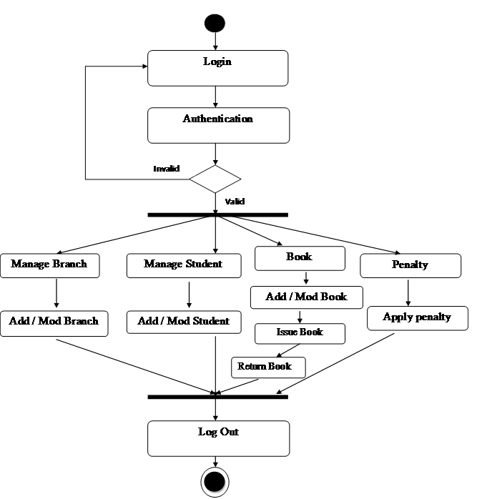

RESULT:

Activity diagram for Library management system is successfully completed .

**17) Activity diagram for online shopping system**

**AIM:**

**To implement and excute Activity diagram for online shopping system.**

**Objective:**

The activity diagram for online shopping

management system is a state chart variation that is

a graphical representation of an executed collection

of procedural purchasing actions. This section goes

into great detail about the parallel and conditional

activities, use cases, and system functions.

Activity diagram for online shopping website Activity

diagram for online shopping system The activity diagram

used to describe flow of activity through a series of

actions. Activity diagram is a important diagram to

describe the system. The activity described as a action

or operation of the system. Activity Diagram for User

procedure:

**Steps on how to create an activity diagram for**

**online shopping management**

* Step 1: Familiarize Activity Diagram Symbols
* First, Activity Diagram Symbols are used to create
* an Activity Diagram which was presented here.

Step 2: Identify the flow of actions. ...

* Step 3: Add the Actors (users) involved. ...
* Step 4: Trace the flow of activities. ...

OUTPUT: 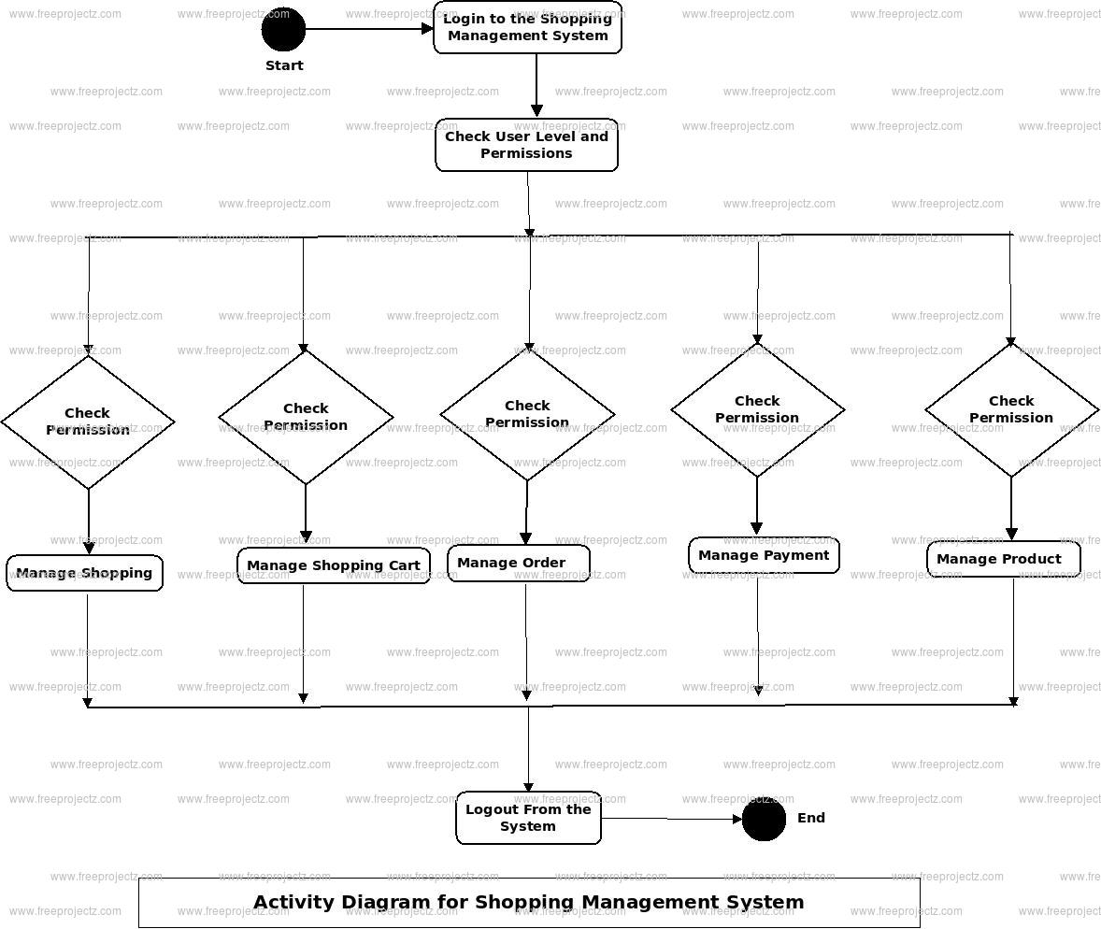

Result:

Activity diagram for Library management system is successfully completed.

18) Activity diagram for online Railway reservation system

AIM:

To implement and excute online railway reservation system.

Objective:

The **activity diagram for online railway reservation system** is a UML activity diagram built to give the proponents the right ideas on how to develop the said software with an explanation.

When designing this system activity diagram, you must show the flow of activities that are done in making railway reservations.

Why is that? It is because this will help you, your readers, and users understand how the software should behave once it is in use. Its activity diagram shows the core of the Railway Reservation System with symbols like actors, swimlanes, and arrows.

Procedure:

Allow me to explain its purpose and role in

greater detail. The Railway Reservation System must

have an activity diagram so that programmers can

understand how the software should interact with its

users.

It is because the activity diagram guides the

programmer in creating the software and its must-

have behavior. So if you want friendly and effective or

easy-to-use software, then you must also complete

the activity diagram.

Through the activity diagram, you’ll be able to

illustrate the flow of activities and know what should

be the interactions between the system and its users.

The activity diagram will also help your readers and

users understand how to use the system. So it is best

for you to explain your thoughts on the railway

reservation system through an activity diagram

OUTPUT:

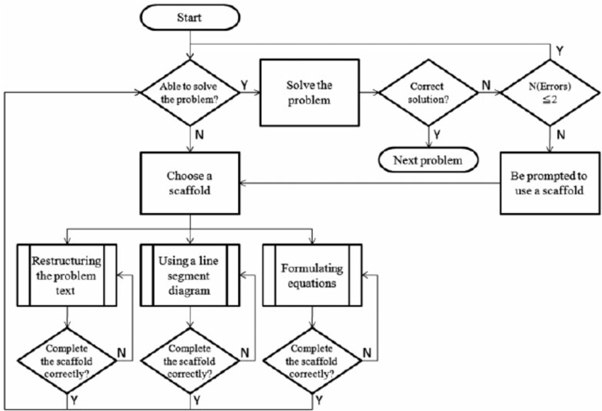

RESULT:

Activity diagram for online railway reservation system is successfully completed.

19) Activity diagram for hospital management system

AIM:

To implement and excute Activity diagram for hospital management system

Objective:

This is a hospital management user interface for managing, monitoring and controlling the system in a Hospital. This application is developed in java, which mainly focuses on basic operations in a hospital like adding new patient information, and updating new information, assigning the doctor for patient. It features a familiar and well thought-out, an attractive online user interface, combined with strong searching Insertion and reporting capabilities. The Backend of the project is designed with Java, MySQL for database connectivity and front end using HTML, CSS, and Bootstrap. This was my Java mini-project for third semester UG.

Procedure:

The activity diagram used to describe flow of activity through a series of actions. Activity diagram is a important diagram to describe the system. An activity diagram shows the overall flow of control**.**

the main activity involved in this UML Activity Diagram of Hospital Management System are as follows: Admin User can search Medicines, view description of a selected Medicines, add Medicines, update Medicines and delete Medicines. Its shows the activity flow of editing, adding and updating of Patient.

Activity Diagram – Hospital Management System Project The activity diagram used to describe flow of activity through a series of actions. Activity diagram is a important diagram to describe the system. An activity diagram shows the overall flow of control. Activity Diagram Symbols  Symbol Description.

* **HTML** is integrated in JSP. It provides a means to structure text based information in a document. It allows users to produce web pages that include text, graphics and  
  hyperlinks.
* **Javascript** is a scripting language which supports the development of both client and server applications. It is preferred at client side to write programs that can be  
  executed by a web browser within the context of a web page.
* **CSS(Cascading Style Sheets)** is a style sheet language used for describing the presentation of a document written in a markup language. Although most often used to set the visual style of web pages and user interfaces written in HTML and XHTML, the language can be applied to any XML document,
* SQL is the language used to manipulate relational databases. It is tied closely with the relational model. It is issued for the purpose of data definition and data  
  manipulation.

OUTPUT:

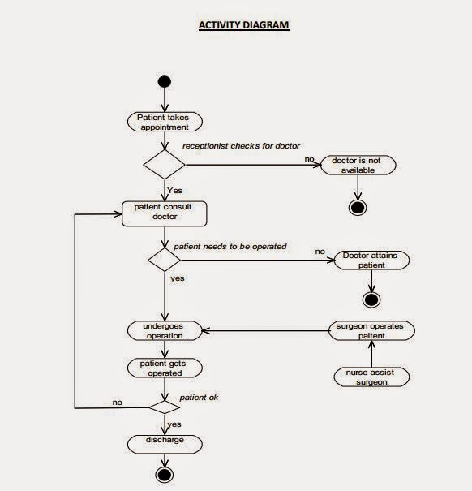

RESULT:

Activity diagram for Hospital management system is successfully completed.

20) Raptor-palindrome or not

AIM:

A flow chat whether the number is palindrome or not

Objective:

Raptor allows the user to write and excute the program using flow charts. The simple language and geographical components of raptor are designed to teach the major ideas of computer programming to the students .it is typically used in academics to teach introductory programming as well.

Procedure:

Step1: from the raptor software application dragging the icons of assignment input and output

Step 2: I am taking 5 assignments , 1 input and 2 output and 2 loop for the effective running of the program

Step 3: filling the assignment ,input and output and loop columns to run the program

OUTPUT:

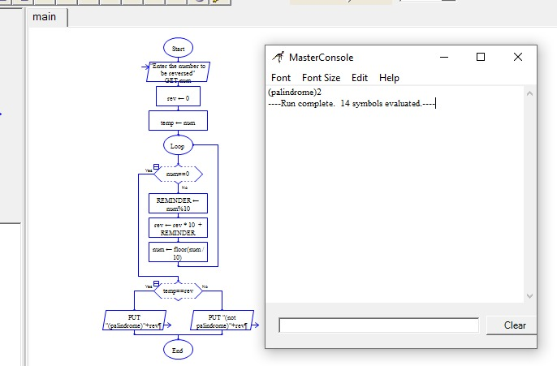

RESULT:

Finally the program is excuted successfully.

21) Flow chart to calculate Fibonacci series

AIM:

A flow chart to calculate Fibonacci series

Objectives:

Raptor allows the user to write and execute the program using flow charts .the simple language and geographical components of raptor are designed to teach the major ideas of computer programming to the students . it is typically used in academics to teach introductory programming as well.

Procedure:

Step1: from the raptor software application dragging the icons of assignment input and output

Step 2: I am taking 5 assignments , 1 input and 2 output and 2 loop for the effective running of the program

Step 3: filling the assignment ,input and output and loop columns to run the program

OUTPUT:

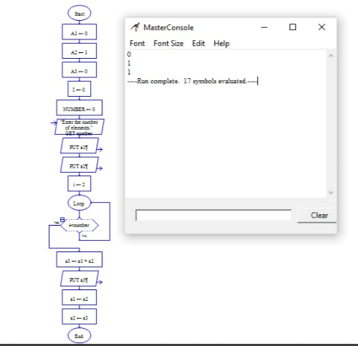

RESULT:

Finally the program is excuted successfully

22)Flow chart to swap two characters

AIM:

A Flow chart to swap two characters

Ojective:

Raptor allows the user to write and execute the program using flow charts .the simple language and geographical components of raptor are designed to teach the major ideas of computer programming to the students . it is typically used in academics to teach introductory programming as well.

Procedure:

Step1: from the raptor software application dragging the icons of assignment input and output

Step 2: I am taking 5 assignments , 1 input and 2 output and 2 loop for the effective running of the program

Step 3: filling the assignment ,input and output and loop columns to run the program

Output:

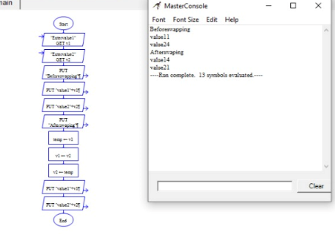

Result:

Finally the program is successfully excuted

23) Flow chart to display the length of the string

AIM:

A Flow chart to display the length of the string

Objectives:

Raptor allows the user to write and execute the program using flow charts .the simple language and geographical components of raptor are designed to teach the major ideas of computer programming to the students . it is typically used in academics to teach introductory programming as well.

Procedure:

Step1: from the raptor software application dragging

the icons of assignment input and output

Step 2: I am taking 5 assignments , 1 input and 2

output and 2 loop for the effective running of the

program

Step 3: filling the assignment ,input and output

and loop columns to run the program.

Output:

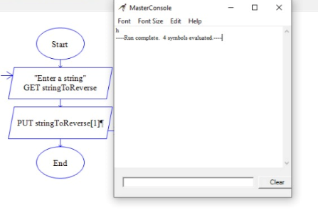

Result:

Finally the program is executed successfully

24) Flowchat to find whether it is prime or not

AIM:

A Flow chart to find whether it is prime or not

Objective:

Raptor allows the user to write and execute the program using flow charts .the simple language and geographical components of raptor are designed to teach the major ideas of computer programming to the students . it is typically used in academics to teach introductory programming as well.

Procedure:

Step1: from the raptor software application dragging

the icons of assignment input and output

Step 2: I am taking 5 assignments , 1 input and 2

output and 2 loop for the effective running of the

program

Step 3: filling the assignment ,input and output

and loop columns to run the program

OUTPUT:

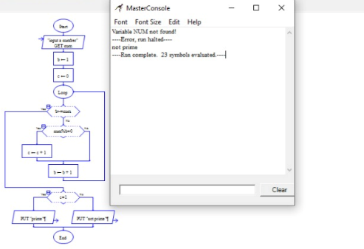

RESULT:

Finally the program is excuted successfully

25) CYCLOMATIC COMPLEXITY

AIM:

A flow chart to find whether it is prime or not

Objective:

Raptor allows the user to write and execute the program using flow charts .the simple language and geographical components of raptor are designed to teach the major ideas of computer programming to the students . it is typically used in academics to teach introductory programming as well

Procedure:

Step1: from the raptor software application dragging

the icons of assignment input and output

Step 2: I am taking 5 assignments , 1 input and 2

output and 2 loop for the effective running of the

program

Step 3: filling the assignment ,input and output and

loop columns to run the program

OUTPUT:

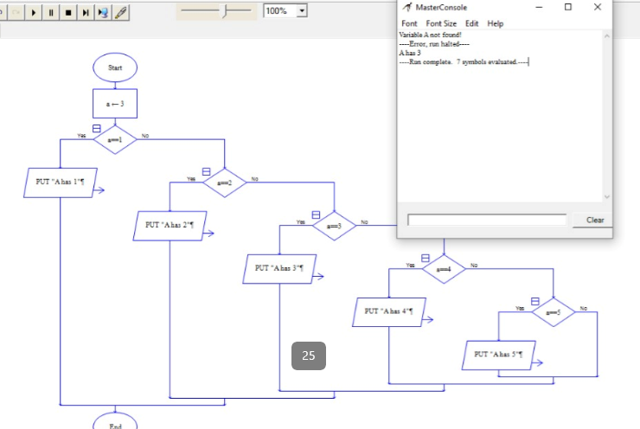

RESULT:

Finally the program is excuted successfully.